Question 2: Hospital Patient Records Dataset
2. A hospital wants to analyze patient admissions and treatment effectiveness. Data were entered manually by different departments, leading to inconsistencies.
Aim
To identify and clean inconsistencies in hospital patient records by handling missing values, duplicate records, invalid dates, null treatment costs, inconsistent diagnosis names, date-format issues, and age outliers, and to evaluate the effect of data cleaning on treatment cost and hospital stay duration.
- Detect all inconsistencies and anomalies
Issue | Records affected | Problem
Missing Patient ID | Kavya R | Patient ID is NULL
Duplicate record | P1005 Rahul P | Same record appears twice
Invalid discharge date | P1002 Priya S | Admission = 12-01-2025, Discharge = 11-01-2025
Missing treatment cost | P1005 Rahul P | Treatment cost is NULL
Unrealistic age | P1003 Arun V | Age is shown as 125, which is unrealistic
Inconsistent diagnosis | P1003, Kavya R, P1008 | diabetes, Diabtes, HYPERTENSION
Date format inconsistency | Dataset | Dates may be entered in different formats
Missing/incorrect ID sequence | Kavya R | Patient ID is missing
Duplicate patient information | Rahul P | Same patient and treatment information repeated

2. Rules for handling missing and invalid values
Missing Patient ID
- Check whether the patient can be uniquely identified using name, age, gender, admission date, and doctor ID.
- If the record is unique, generate a new ID such as P1010.
- If identification is uncertain, mark the record for manual verification.
Invalid Age
- Acceptable age range: 0–120.
- Age 125 should be treated as an outlier/error.
- Verify against the patient's registration record.
- Correct it if the actual age is available; otherwise mark it as missing.
Invalid Dates
- Convert all dates to one standard format: YYYY-MM-DD.
- Cleaning Methods:
Problem | Cleaning Method
Missing Patient ID | Generate a new unique ID
Duplicate record | Remove duplicate
Age > 120 | Replace with missing value and use median
Missing treatment cost | Replace with median treatment cost
Invalid discharge date | Remove/verify the record
Inconsistent diagnosis | Standardize using mapping
Date inconsistency | Convert to standard datetime format

- Data Transformation
Transformations Performed
- Convert admission date to datetime.
- Convert discharge date to datetime.
- Standardize diagnosis names.
- Calculate hospital stay in days.
- Apply consistent data types.
Program:
import pandas as pd
import numpy as np
# CREATE THE HOSPITAL PATIENT DATA
data = {
"PatientID": [
"P1001", "P1002", "P1003", None, "P1005",
"P1005", "P1006", "P1007", "P1008", "P1009"
],
"Name": [
"Ravi Kumar", "Priya S", "Arun V", "Kavya R", "Rahul P",
"Rahul P", "Sneha M", "Deepak N", "Meena K", "John D"
],
"Age": [
45, 38, 125, 29, 51,
51, 34, 35, 26, 40
],
"Gender": [
"M", "F", "M", "F", "M",
"M", "F", "M", "F", "M"
],
"AdmissionDate": [
"10-01-2025", "12-01-2025", "13-01-2025", "15-01-2025",
"18-01-2025", "18-01-2025", "15-01-2025", "01-02-2025",
"10-02-2025", "12-02-2025"
],
"DischargeDate": [
"15-01-2025", "11-01-2025", "20-01-2025", "17-01-2025",
"25-01-2025", "25-01-2025", "18-01-2025", "05-02-2025",
"15-02-2025", "18-02-2025"
],
"Diagnosis": [
"Diabetes", "Hypertension", "diabetes", "Diabtes", "Asthma",
"Asthma", "Hypertension", "Asthma", "HYPERTENSIO N", "Diabetes"
],
"TreatmentCost": [
25000, 18000, 22000, 15000, None,
None, 12000, 10000, 13500, 20000
],
"DoctorID": [
"D101", "D102", "D101", "D103", "D104",
"D104", "D102", "D104", "D102", "D101"
]
}
df = pd.DataFrame(data)
print("=" * 60)
print("ORIGINAL HOSPITAL PATIENT DATA")
print("=" * 60)
print(df)
# TASK 1: DETECT INCONSISTENCIES AND ANOMALIES
print("\n\n" + "=" * 60)
print("1. DETECT INCONSISTENCIES AND ANOMALIES")
print("=" * 60)
# Missing Patient IDs
print("\nMissing Patient IDs:")
print(df[df["PatientID"].isna()])
# Duplicate records
print("\nDuplicate Records:")
print(df[df.duplicated(keep=False)])
# Missing Treatment Costs
print("\nMissing Treatment Costs:")
print(df[df["TreatmentCost"].isna()])
# Unrealistic ages
print("\nUnrealistic Ages:")
print(df[(df["Age"] < 0) | (df["Age"] > 120)])
# Convert dates
df["AdmissionDate"] = pd.to_datetime(
df["AdmissionDate"], dayfirst=True, errors="coerce"
)
df["DischargeDate"] = pd.to_datetime(
df["DischargeDate"], dayfirst=True, errors="coerce"
)
# Invalid discharge dates
print("\nInvalid Discharge Dates:")
print(
df[df["DischargeDate"] < df["AdmissionDate"]]
)
# Inconsistent diagnosis values
print("\nDiagnosis Values:")
print(df["Diagnosis"].unique())
# TASK 2: HANDLE MISSING AND INVALID VALUES
print("\n\n" + "=" * 60)
print("2. HANDLING MISSING AND INVALID VALUES")
print("=" * 60)
# Remove exact duplicate records
df_clean = df.drop_duplicates().copy()
# Generate Patient ID for missing ID
df_clean.loc[
df_clean["PatientID"].isna(), "PatientID"
] = "P1010"
# Replace unrealistic age with NaN
df_clean.loc[
(df_clean["Age"] < 0) | (df_clean["Age"] > 120),
"Age"
] = np.nan
# Fill missing age with median age
df_clean["Age"] = df_clean["Age"].fillna(
df_clean["Age"].median()
)
# Fill missing treatment cost using median
# of available treatment costs
df_clean["TreatmentCost"] = df_clean["TreatmentCost"].fillna(
df_clean["TreatmentCost"].median()
)
# Remove records with invalid discharge date
df_clean = df_clean[
df_clean["DischargeDate"] >= df_clean["AdmissionDate"]
].copy()
print("\nCleaned Data:")
print(df_clean)
# TASK 3: STANDARDIZE DIAGNOSIS NAMES
print("\n\n" + "=" * 60)
print("3. STANDARDIZING DIAGNOSIS NAMES")
print("=" * 60)
# Remove extra spaces and convert to lowercase
df_clean["Diagnosis"] = (
df_clean["Diagnosis"]
.str.strip()
.str.lower()
.str.replace(" ", "", regex=False)
)
# Correct spelling variations
diagnosis_map = {
"diabetes": "Diabetes",
"diabtes": "Diabetes",
"hypertension": "Hypertension",
"hypertensio": "Hypertension",
"asthma": "Asthma"
}
df_clean["Diagnosis"] = df_clean["Diagnosis"].replace(
diagnosis_map
)
print("\nStandardized Diagnosis:")
print(df_clean[["PatientID", "Diagnosis"]])
# CALCULATE HOSPITAL STAY
df_clean["HospitalStay"] = (
df_clean["DischargeDate"] -
df_clean["AdmissionDate"]
).dt.days
print("\nHospital Stay:")
print(df_clean[["PatientID", "HospitalStay"]])
# TASK 4: COMPARE AVERAGE COST AND HOSPITAL STAY
print("\n\n" + "=" * 60)
print("4. BEFORE AND AFTER CLEANING")
print("=" * 60)
# Average cost before cleaning
original_average_cost = df["TreatmentCost"].mean()
# Hospital stay before cleaning
original_stay = (
df["DischargeDate"] - df["AdmissionDate"]
).dt.days
original_average_stay = original_stay.mean()
# Average cost after cleaning
clean_average_cost = df_clean["TreatmentCost"].mean()
# Average stay after cleaning
clean_average_stay = df_clean["HospitalStay"].mean()
print("\nBefore Cleaning:")
print("Average Treatment Cost:",
round(original_average_cost, 2))
print("Average Hospital Stay:",
round(original_average_stay, 2), "days")
print("\nAfter Cleaning:")
print("Average Treatment Cost:",
round(clean_average_cost, 2))
print("Average Hospital Stay:",
round(clean_average_stay, 2), "days")
# TASK 5: DATA GOVERNANCE RECOMMENDATIONS
print("\n\n" + "=" * 60)
print("5. DATA GOVERNANCE MEASURES")
print("=" * 60)
OUTPUT:
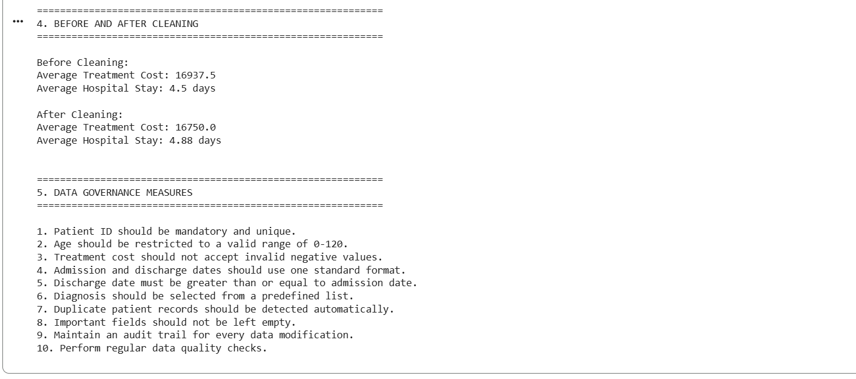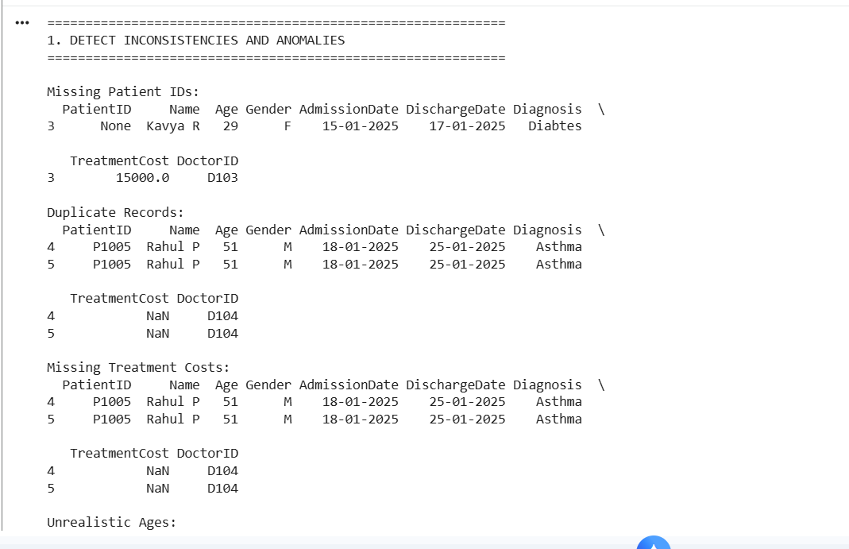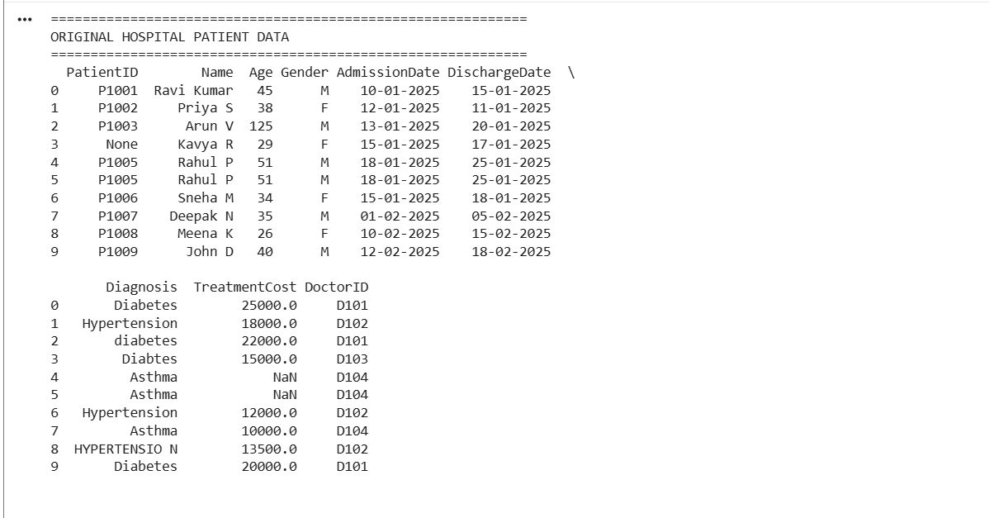

Question 3: Banking Loan Approval
1.Anomaly Detection
Customer ID | Anomaly | Description
L003 | Missing value | Credit Score is NULL
L002 | Inconsistent format | Annual Income is 900K
L004 | Invalid value | Loan Amount is -200000
L008 | Duplicate | Customer L008 appears twice
L005 | Invalid age | Age is 16, below the valid minimum of 18
L002, L003, L008 | Inconsistent values | FT, fulltime, and Full Time
L007 | Outlier | Annual Income is 75000000

Code
import pandas as pd
import numpy as np
data = {
"CustomerID": ["L001","L002","L003","L004","L005",
"L006","L007","L008","L008","L010"],
"AnnualIncome": [750000,"900K",1200000,150000,5000000,
450000,75000000,650000,650000,None],
"CreditScore": [720,680,None,450,790,350,800,690,690,710],
"LoanAmount": [300000,400000,600000,-200000,1000000,
250000,500000,350000,350000,300000],
"EmploymentStatus": [
"Full Time","FT","fulltime","Part Time","Self Employed",
"Unemployed","Full Time","FT","FT","Full Time"
],
"Age": [35,42,28,30,16,40,45,33,33,37],
"ExistingDebt": [50000,100000,200000,50000,10000,
300000,100000,70000,70000,80000],
"LoanStatus": [
"Approved","Approved","Approved","Rejected","Approved",
"Rejected","Approved","Approved","Approved","Approved"
]
}
df = pd.DataFrame(data)
print("Missing Credit Scores:")
print(df[df["CreditScore"].isna()])
print("\nDuplicate Customer IDs:")
print(df[df.duplicated("CustomerID", keep=False)])
print("\nNegative Loan Amounts:")
print(df[df["LoanAmount"] < 0])
print("\nInvalid Ages:")
print(df[df["Age"] < 18])
print("\nEmployment Status:")
print(df["EmploymentStatus"].unique())
OUTPUT:
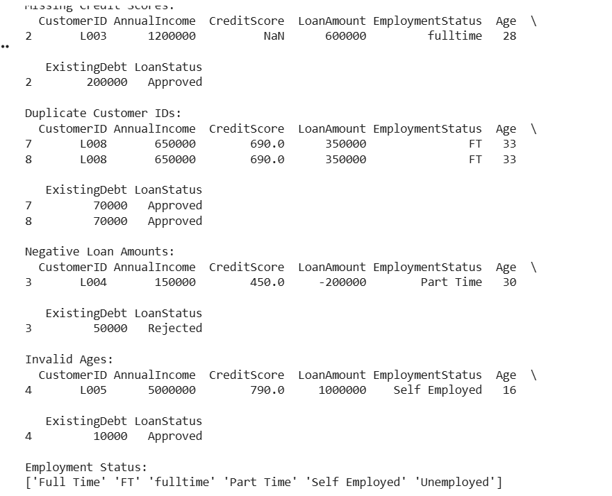
2. Cleaning Methods
The following cleaning methods are applied:
- Convert 900K into 900000.
- Replace missing credit score with the median credit score.
- Standardize FT and fulltime as Full Time.
- Remove duplicate L008 record.
- Remove the invalid negative loan amount.
- Remove the applicant below 18 years
Code:
def convert_income(x):
if pd.isna(x):
return np.nan
if isinstance(x, str) and x.upper().endswith("K"):
return float(x[:-1]) * 1000
return float(x)
df["AnnualIncome"] = df["AnnualIncome"].apply(convert_income)
# Fill missing credit score with median
df["CreditScore"] = df["CreditScore"].fillna(
df["CreditScore"].median()
)
df["EmploymentStatus"] = df["EmploymentStatus"].replace({
"FT": "Full Time",
"fulltime": "Full Time"
})
df = df.drop_duplicates("CustomerID")
# Remove negative loan amount
df = df[df["LoanAmount"] >= 0]
# Remove invalid age
df = df[df["Age"] >= 18]
print("Cleaned Data:")
print(df)
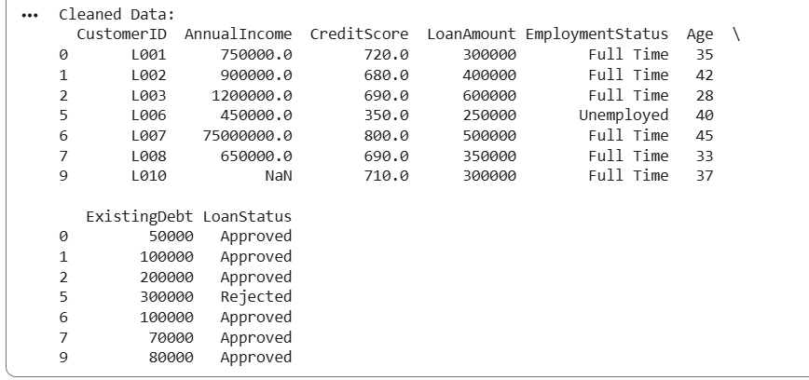
3. Data Transformation
The cleaned data is transformed into a form suitable for analysis.
Transformations
- Convert income values to a common numerical unit.
- Standardize employment status.
- Calculate the Debt-to-Income Ratio.
- Detect extreme income values using the IQR method.
Code:
# Debt-to-Income Ratio
df["DebtToIncome"] = (
df["ExistingDebt"] / df["AnnualIncome"]
) * 100
# IQR method for income outliers
Q1 = df["AnnualIncome"].quantile(0.25)
Q3 = df["AnnualIncome"].quantile(0.75)
IQR = Q3 - Q1
lower_limit = Q1 - 1.5 * IQR
upper_limit = Q3 + 1.5 * IQR
df["IncomeOutlier"] = np.where(
(df["AnnualIncome"] < lower_limit) |
(df["AnnualIncome"] > upper_limit),
"Yes",
"No"
)
print(df[
["CustomerID", "AnnualIncome",
"DebtToIncome", "IncomeOutlier"]
])
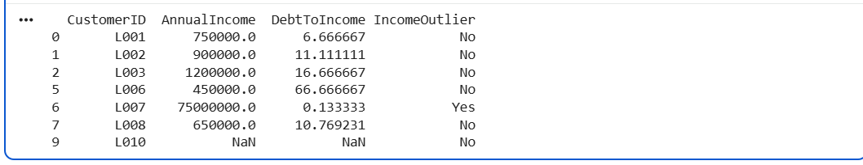
4. Analytical Comparison
The loan approval rate is compared before and after cleaning.
Output:
Approval Rate Before Cleaning: 80.0 %
Approval Rate After Cleaning: 85.71 %

